- Project Title: Company Info Extractor: AI-Powered Data Retrieval

- Project Statement and Outcomes:
- Develop a Python script leveraging ChatGPT-4 via OpenAI's API to automate the extraction of comprehensive company information from the web. The script should input company names from an input field and retrieve publicly available details such as email, phone number, website, address, city, and postal code. The objective is to create a user-friendly tool that efficiently formats the data into a UI for easy access and analysis.
- The project delivers a Python script powered by ChatGPT-4, which automates the extraction of company information from the web. Users input company names via an input field through UI, and the script retrieves publicly available details such as email, phone number, website, address, city, and postal code, formatting them as an output.. Accompanied by clear documentation, the tool ensures straightforward execution, even for non-technical users, with robust error handling for seamless operation.

3. Modules to be Implemented:
- Project Setup & OpenAI Integration Module
- Langchain Integration & Data Extraction Module
- Streamlit integration & UI module
- Review, Bug Fixes, & Documentation

4. Week-wise module implementation and high-level requirements:
- Week 1-2: Project setup & OpenAI Integration Module
- High-Level Requirements:
  - Set up the development environment, version control system, and project management tools.
  - OpenAI Integration.
  - Handle response processing and error checking.
- Week 3-4: Langchain Integration Module
- High-Level Requirements:
  - Integrating Langchain framework with OpenAI
  - Integrating Langchian Agents for accessing internet data.
  - Data correction and validation.
- Week 5-6: Streamlit Integration & UI development
- High-Level Requirements:
  - Understanding Streamlit
  - Integrating Streamlit with the AI Model.
  - Develop a clean UI that takes the company name & displays the Info.
- Week 7-8: Review, Bug Fixes, & Documentation
- High-Level Requirements:
  - Conduct a thorough review of the entire system, including functionality, security, and user interface.
  - Address any identified bugs or issues and perform necessary fixes.
  - Prepare comprehensive documentation covering system architecture, user guides, and technical specifications.
5. Diagrams:
      - 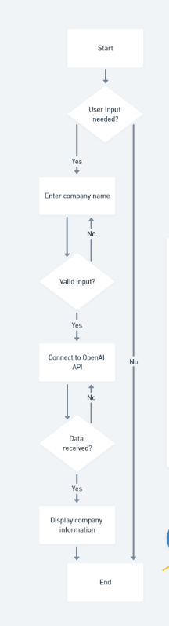

6. Sample Input:
The user interacts with the application through the UI and gives the company name as the input.

7. Sample Output:
The output will be the company details that were fetched from the web.
